IT24100191

Jayasinghe D.B.P

01)

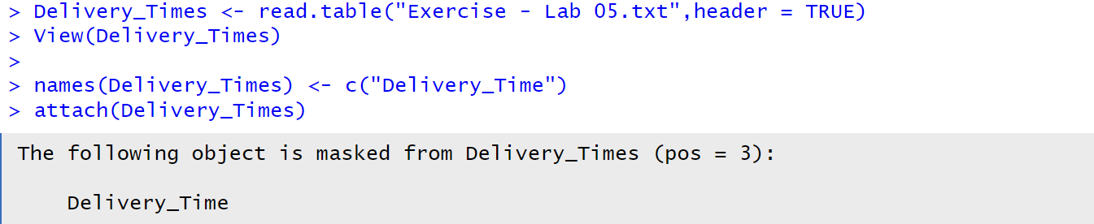

02)



03)

It is roughly symmetric and not strongly skewed. Values range between 20 and 70.

04)



